**Tableau Project: Bank Customer Churn Analysis**

**Data source:** <https://www.kaggle.com/datasets/radheshyamkollipara/bank-customer-churn>

**Tableau Public Project Link**: <https://public.tableau.com/shared/FJ7RRGD24?:display_count=n&:origin=viz_share_link>

**Customer overview**: ‘About our customers’ dashboard provides a comprehensive snapshot of our customer base, comprising 10,000 individuals. Key insights include a 20% churn rate, with 2,038 customers having exited the bank. The gender distribution indicates 55% male and 45% female customers. Geographically, 50% are from France, while Germany and Spain contribute 25% each. On average, customers possess 1.5 products, with an average annual income of $100,090 and an average age of 39. This overview offers valuable data for strategic decision-making and targeted initiatives.

**CONCLUSIONS**

* The rate of customer churn is higher among female customers (25%) compared to male customers (16%).
* Individuals aged between 45 and 55 are most inclined to discontinue their relationship with the bank.
* Customers who have filed complaints exhibit a higher likelihood of leaving the bank.
* Germany stands out with the highest churn rate at 32.4%.
* Customers with a credit score of 425 or lower are more prone to churning, while there is no notable change in the churn rate for those with a credit score exceeding 450.

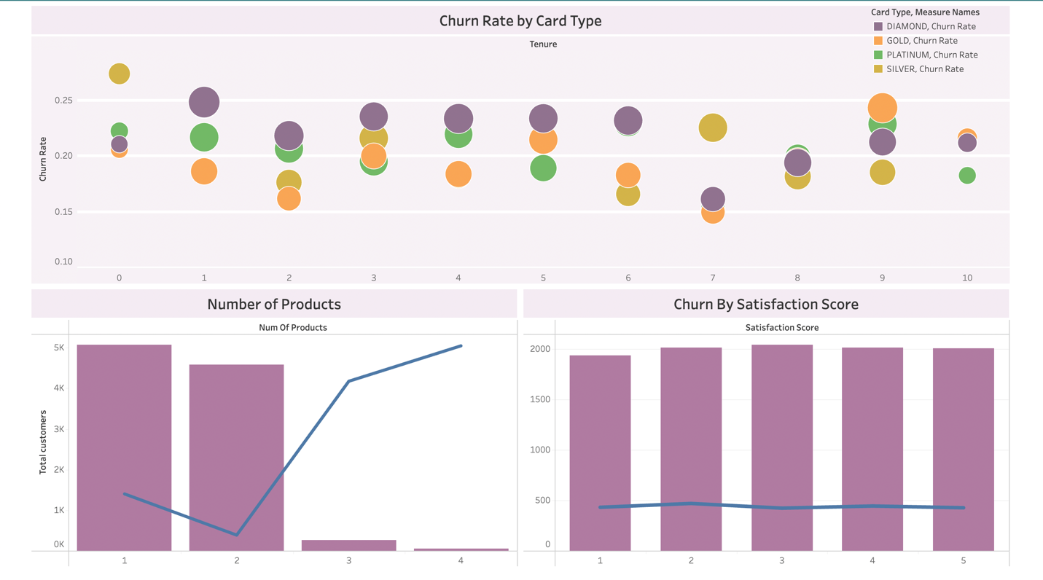

• Among customers who have been with the bank for less than 7 years, diamond cardholders demonstrate the highest churn rates, whereas gold cardholders exhibit the lowest.

• Customers with more than 2 products are at a heightened risk of leaving the bank.

• Churn rates remain consistent across various satisfaction survey scores.

**Suggestions:**

**Targeted Retention Strategies:**

Implement targeted retention strategies for female customers to address the higher churn rate compared to male customers. This may involve personalized communication or loyalty programs tailored to female preferences.

**Focus on Middle-Aged Customers:**

Develop specific retention initiatives for customers aged between 45 and 55, as they are identified as the most likely group to leave. This could include personalized offers, improved customer service, or exclusive benefits.

**Proactive Complaint Resolution:**

Proactively address and resolve customer complaints to mitigate the likelihood of churn. Improving complaint resolution processes and customer satisfaction post-complaint could help retain these customers.

**Localization Efforts in Germany:**

Implement targeted efforts in Germany, where the churn rate is highest. Localized marketing campaigns, improved customer service, or tailored promotions could be explored to enhance customer loyalty.

**Credit Score-Based Interventions:**

Develop interventions for customers with credit scores of 425 and lower, such as offering financial counseling, personalized assistance, or specialized services to improve their banking experience and decrease the likelihood of churn.

**Differentiated Services for Cardholders:**

Tailor services for customers with varying lengths of association with the bank. For example, focus on improving the retention of diamond cardholders who have been with the bank for less than 7 years by offering exclusive benefits or targeted loyalty programs.

**Enhanced Customer Engagement for Multi-Product Users:**

Engage customers with more than 2 products through personalized communication, exclusive offers, or bundled services to increase their satisfaction and reduce the likelihood of churn.

**Continuous Monitoring of Customer Satisfaction:**

While satisfaction survey scores may not directly correlate with churn rates, continuous monitoring and proactive measures to address emerging issues can contribute to overall customer retention.